How to Find the Right ISO Standard
A tool from the Optics and Electro-Optics Standards Council
Rev 1, 3.3.26, JLMichels

Table of Contents

- Introduction
- Selecting an ISO Technical Committee
- Searching for ISO documents
- Finding key information about an ISO document
- Alternate methods of finding ISO documents
- Determining the status of an ISO document
- Contacting the OEOSC

Acronyms
ISO = International Organization for Standardization
OEOSC = Optics and Electro-Optics Standards Council (the US reps for ISO)
SC = Subcommittee
TC = Technical Committee

Appendices
Appendix A. TC 172 Definition and Subcommittee Structure

- Introduction

This document will lead you through the steps to find the right ISO standard for your work. Though these steps will not give you access to the full ISO document, they will lead you to critical information that will help you to decide whether or not to purchase the standard. We also show (in Part 6) how to determine the status of an ISO document.

Things to know before we delve in:

- An ISO document number will be something like: ISO 9335, or ISO 10110-6, or ISO 12233:2024
- ISO document numbers do not contain information about the subject of that document.
- Some documents are optical instrument specific (i.e., endoscopes), while others are general (i.e., how to measure stray light).
- If you want more information before buying, or you are not finding the standard you need, Contact Us at www.oeosc.org/about-us/contact-us/. Although we cannot send you a copy of the document, we can certainly tell you what is inside, and we may have more advice.
- You may purchase ISO standards from www.iso.org, or the ANSI Webstore at https://webstore.ansi.org/
- Finally, congratulations! It’s smart to consider standards! We hope this guide makes the search smooth.

- Selecting an ISO Technical Committee

It is helpful to know what ISO Technical Committee (TC) you need prior to your search. ISO is comprised of hundreds of Technical Committees. The OEOSC represents the US in TC 172 – Optics and Photonics. TC 172 has nine Subcommittees (SC), from which seven are active and two (SC 2 and SC 8) are disbanded. A list of these subcommittees and their descriptions are given in Appendix A below.

Generally, you will be looking in www.iso.org for documents listed within TC 172, but here are some related TCs that may apply to your work (the full list can be found at https://www.iso.org/technical-committees.html):

TC 12 – Quantities and units
TC 20 – Aircraft and space vehicles
TC 36 – Cinematography
TC 42 – Photography (we have a liaison with this TC)
TC 209 – Cleanrooms
TC 211 – Geographic Information (i.e., remote sensing, sensor calibration)
TC 213 – Dimensional and geometrical product specifications and verification (dimensional and geometrical tolerancing, and surface properties for general materials)
TC 229 – Nanotechnologies
TC 261 – Additive manufacturing
TC 274 – Light and lighting

Though we do not have access to documents in these TCs, we still may be of help.

- Searching for ISO documents

Go to https://www.iso.org/technical-committees.html and click on your TC of choice:

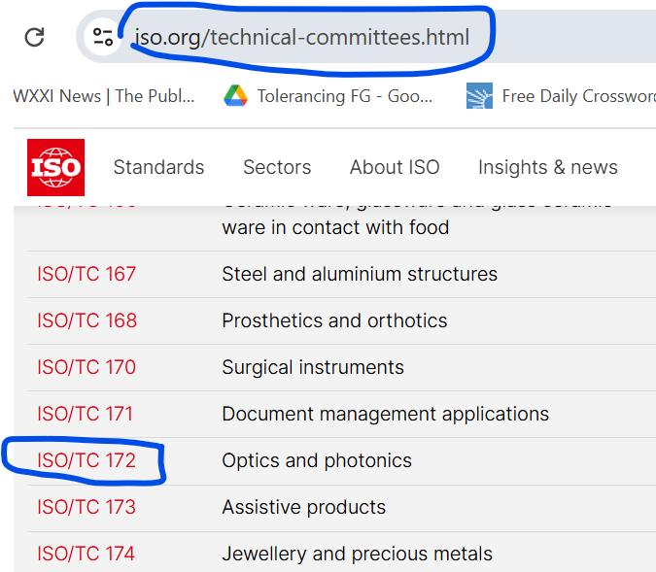

Figure 1. Selecting the Technical Committee

Scroll down to see some statistics:

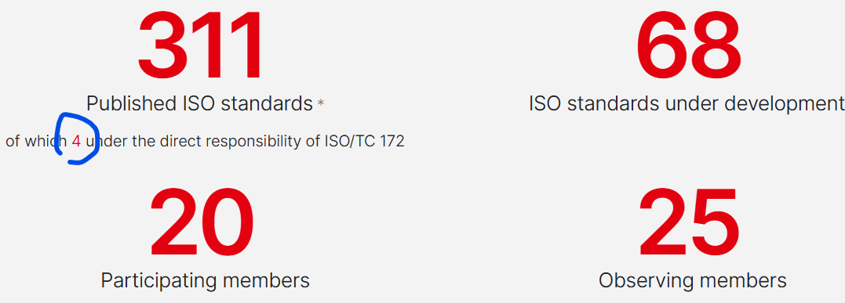

Figure 2. Statistics on Technical Committee landing page

You’ll see the total number of documents in this TC, and just below, the number of documents that do not fall into any Subcommittee. Click on the “4” to see a list of these top-level documents. On the bottom, you can find out which member countries participate (vote and work on standards), and all that observe.

Scrolling down further, you will see a list of the Subcommittees that make up the Technical Committee. The remaining (311 minus 4, in this case) documents are organized into these Subcommittees:

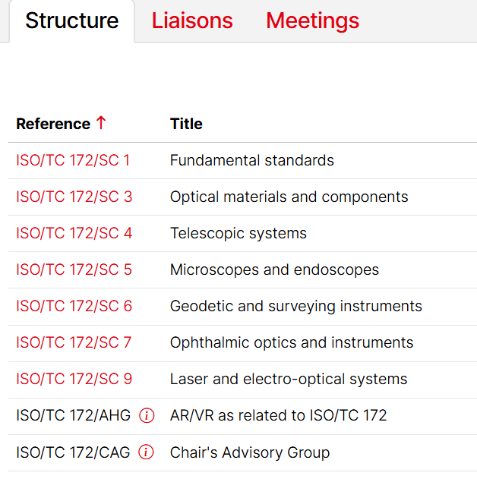

Figure 3. Technical Committee Subcommittees (SCs)

Clicking on any Subcommittee (i.e., ISO/TC 172/SC1) will give you a Scope statement for that SC. Hopefully, the Scope statements will help you to select a Subcommittee. If not, go back to the 311, click on it, and you will see the titles of all 311 documents in TC 172.

- Finding key information about an ISO document
Whether at the TC level or the SC level, click on the number of “Published ISO Standards” (currently 311) for a list of the names of the documents. For any document of interest, click on the document number (i.e., ISO 517:2008). Likewise, you can type that document number into the upper right-hand corner of www.iso.org.

Here, you can determine when the document was last published and confirmed, read the document Abstract, and find the price.

Next, click on “Read sample” under the graphic of the first document page in the upper left-hand corner to find:

Foreword: The beginning of this section is boilerplate. If the document has been revised, this section will also contain a summary of the changes that were made.
Scope: This section often contains useful information in addition to the Abstract.
Normative References: This section is included when another ISO document must be used to properly make use of the present document.
Terms and Definitions: Not all documents have this section, but it can be helpful to understand what is in the document.
Table of Contents (see the left-hand column): This is a sneak peek at the content and detail in the document.
Annexes and Bibliography can be helpful in understanding the detail in the document.

- Alternate methods of finding ISO documents
A more general search may be needed if you do not know what Technical Committee to search.
  - At OEOSC, we have found that general Google searches are not terribly helpful
  - There is an advanced search within www.iso.org called the Online Browsing Platform (OBP). The author has not had much luck using this tool, but you may try!
  - OpenAI tends to work much better. As always, there can be blatant errors, but once you have your document number, it’s easy to enter it into www.iso.org in the search area in the upper right-hand corner and find out more.
  - We have lists posted at www.oeosc.org/oeosc-training/resources/that may be of help. For instance, we have lists of all ISO tests in 10 topical categories, and a list of documents about optical and infrared materials sorted by topic.
Once you have a possible document number, go back to parts 3 and 4 above.

- Determining the status of an ISO document
You may want to know if a document of interest is in the process of being revised, or if any new documents are being prepared for the first time.

Below is an example of a published document. It was last published in 2010. Every five(5) years, all documents are reviewed. This document was reviewed in 2015, 2020, and 2025. In each case, members voted and decided not to revise the document. The document Stage is 90 (see Table 1 below).

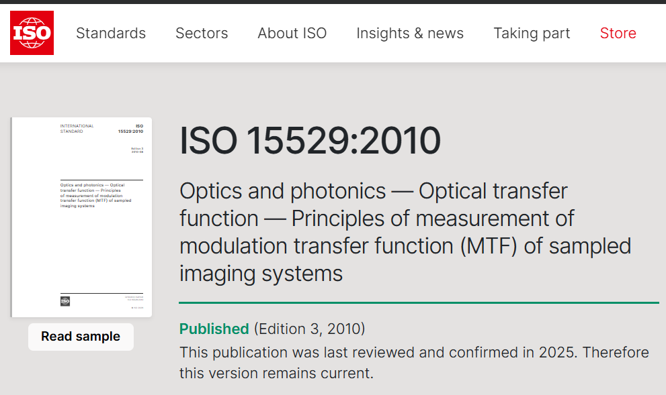

Figure 4. Example of a published document.

When the members decide to revise a document, it is taken through a series of stages. This process takes roughly five(5) years. You can assume that the process is somewhat linear in time with the stage number, which can be found using one of the methods below.

METHOD 1. To see all documents under development in a TC or an SC, click on the red number above “ISO standards under development.” See Figures 1 and 2 above. For instance, for TC 172, that number is currently 68). You will then see a list of documents under development for each Subcommittee (for example, there are 6 documents currently under development for SC 1). Click on the 6, and you will see a list of 6 documents, each with a Stage number.

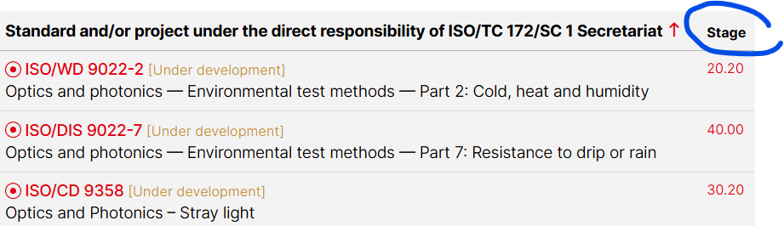

METHOD 2. If you have a particular document number of interest, such as ISO 6760-1, into the search box in the upper right hand corner of www.iso.org. Click on the document number (currently ISO 6760-1:2025), scroll down to the Life cycle information, and locate the Stage number:
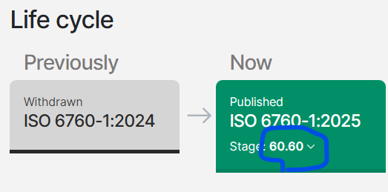

Table 1. Stage number definitions.
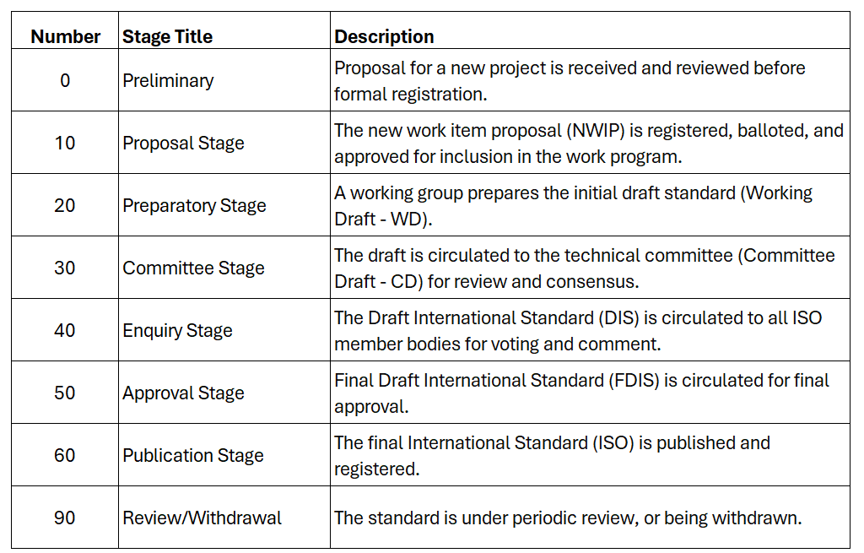
Feel free to contact us about the changes that are occurring when a document is in revision. In the meantime, you should use the latest published edition (i.e., 2010 in the case of Figure 4 above).

- Contacting the OEOSC

For more information, send a note through About Us/Contact Us at www.oeosc.org/about-us/contact-us/ and we can get you in touch with the appropriate OEOSC member.

Appendix A. TC 172 Definition and Subcommittee Structure

Scope of ISO/TC 172: Standardization of terminology, requirements, interfaces and test methods in the field of optics and photonics. This includes complete systems, devices, instruments, ophthalmic optics, optical and photonic components, auxiliary devices and accessories, as well as materials. Optics and photonics are used in the meaning of generation, handling and detection of optical radiation including signal processing.

Excluded: standardization for specific items in the field of cinematography (ISO/TC 36), photography (ISO/TC 42), eye protectors (ISO/TC 94), micrographics (ISO/TC 171), fibre optics for telecommunication (IEC/TC 86) and electrical safety of optical elements, and general lighting.

The members of each of the Subcommittees are listed at www.oeosc.org/tag-member-roster/. If you do not see the contact information, you can send a note through About Us/Contact Us at oeosc.org and we can get you in touch with the appropriate OEOSC member.

SC 1 Fundamental standards (1986)

Subcommittee SC 1 covers the standardization of terminology, requirements and test methods which apply to the whole field of ISO/TC 172, such as drawing specifications, general optical test methods, environ-mental test methods as well as data transfer and codification.
Actually, optical systems consist more and more of special components such as aspherical, cylindrical and so-called free-form surfaces used for different applications. Therefore, new requirements arise for characterization and specification (for product and quality properties). In addition, new metrology processes are required which have to be standardized.

SC 3 Optical materials and components (1985)

Subcommittee SC 3 covers the standardization of terminology, requirements and test methods for optical materials and components. Those include optical glasses and infrared materials, and coatings. SC 3 covers all segments of the photonics market directly or indirectly. Optical materials and components are used in products such as lenses, optical windows, mirrors, etc. Optical materials have been improved in performance, along with advances in miniaturization and high precision of optical systems. Optical glasses with especially high refractive index or with abnormal dispersion have developed in recent years. The needs for infrared materials are increasing because of applications such as security cameras and automotive cameras. Contributions to the market are to develop International Standards which ensure the optical materials and components are safe, reliable and of good quality.

SC 4 Telescopic systems (2019)

This includes monocular and binocular telescopic systems supported by hand or tripod, telescopic sights that are mounted on firearms and amateur astronomical telescopes. Telescopic systems containing integral light sources, displays and electronic detectors sensors, including amplifying detectors, image sensors and microprocessor control of these systems are included as well. Components and accessory devices used with these telescopic systems, such as eyepieces, tripods and light shields, as well as their interfaces are also included. Standardization of terms and definitions pertaining to these optical systems and test methods to assess their optical performance (including user comfort and ergonomics) as well as their performance under varying environmental conditions. Excluded are video cameras used for recording distant objects and surveying instruments.

SC 5 Microscopes and endoscopes (1985)

The products include light and operating microscopes, and flexible and rigid endoscopes and endotherapy devices.
One of the important areas for light microscopes are confocal microscopes, but the trend for the next years will be in automation. Microscopes are and will increasingly be controlled by software only, and therefore new or revised standards will be required with regard to magnification, calibration etc. For the operating microscopes some of the industry trends are with navigation systems.
For rigid and flexible endoscopes and endotherapy devices some of the major technological and industrial trends are video, miniaturization, computer-assisted surgery and energy systems.

SC 6 Geodetic and surveying instruments (1981)

Products in this area include total stations, laser tracker, laser scanner, levels, construction lasers, hand-held distance meters, global navigation satellite systems (GNSS), monitoring systems, mining solutions, machine control systems and airborne sensors. The segment depends a lot on the world-wide construction industry and usually shows stable growth. All technologies in this area seem to grow likewise. If there are differences then there might be a slightly different technology trend for laser scanners, machine control systems and GNSS.

SC 7 Ophthalmic optics and instruments (1981)

The market of ophthalmic goods is categorized into diagnostic and monitoring devices, surgical devices, and vision care products (prescription lenses and contact lenses).
The growth of this market is largely driven by technological advancements in the ophthalmology devices. The market witnessed an increase due to increased patient acceptance of surgical procedures including diagnosis and treatment. The global increase in the aging population has triggered the prevalence of eye disorders worldwide thus providing an impetus to the ophthalmology devices market by increased demand. However, the growth of this market is hampered by the factors like economic slowdown due to eurozone crisis which has negatively affected the ophthalmology device manufacturers. The reimbursement issues also pose threat to the ophthalmology devices market to a certain extent. North America accounted for the largest share in the global market followed by Europe, APAC, and RoW. However, the developed regions like North America and Europe are expected to grow at a slower pace during the forecast period due the saturation in these markets. The Asian region on the other hand is anticipated to grow at a faster pace due to the changing lifestyles and rising per capita incomes boosting the demand for ophthalmology devices in this region.

SC 9 Laser and electro-optical systems (1985)

Many different products fall in this category including lasers, surgical equipment used with lasers in the operating room, optical components such as lenses and mirrors, microlens arrays and diffractive optics.
Lasers find non-military applications in medicine, industry, information technology and elsewhere. Although liquid lasers (dye lasers in particular) have been significant in the past, today’s lasers are almost always based on either solid state or gaseous media. Within the solid state category, there are several subdivisions. Although semiconductor devices are surely solid state devices, semiconductor lasers are considered to be a category of their own, and not “solid state” lasers. Fiber lasers are often treated similarly, considered to be a category of their own. In this narrow sense, “solid state” lasers are only those based on bulk, non-semiconductor solid materials.
For the past decade or longer, an important trend has been the intrusion of fiber lasers into markets that were previously the exclusive domain of conventional, bulk solid state lasers. Because the ratio of surface area to volume is so great for a fiber laser, heat removal is greatly facilitated and, as a result, the beam quality from a fiber laser is superior to that from a conventional solid state laser. Fiber lasers can also be lighter and more rugged than conventional solid state lasers. For these reasons, the trend of fiber lasers replacing conventional solid state lasers is likely to continue into the future.
Because lasers find such a broad variety of applications, it is important the parameters of laser performance be carefully standardized. SC 9 has created and maintains standards for all these parameters, including beam quality (divergence), power, energy and temporal characteristics, polarization, positional stability, spectral characteristics, and lifetime.
Lasers have many advantages over conventional surgical instruments and are widely utilized in operating rooms throughout the world. But lasers create a fire hazard in the operating room, and patients die every year from accidental, laser-induced fires. To reduce this hazard, SC 9 creates and maintains standards for measuring the laser-induced flammability of drapes and tracheal tubes used in conjunction with laser surgery.
The optical components used with a laser, and especially those inside the laser, are crucial to the laser’s performance. SC 9 creates and maintains standards for these components, which include mirrors, lenses, polarizers, windows as well as active components like modulators and nonlinear crystals. These standards define measurement techniques for scattering, absorptance, specular reflection and transmission, and optically induced damage.

